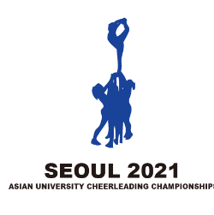 |  | 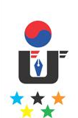
3rd Asian University Cheerleading Championship
Online, 4th Sep. – 15th Oct. 2021
OC Email: ausfaucc@gmail.com, Tel: +82-10-54788814
Received on: | Quantitative Entry Form
 |  |  | Q

Country/Region: |  | Country Code:
Name of the NUSF:

* National University Sports Federation (NUSF)
Please fill in this table a numerical estimation of participants.
Delegation |  |  | Male | Female | Sub-total
Competitors | Team cheer | Premier Large Coed (16-20 athletes)
 |  | Premier Small Coed (16-20 athletes)
 |  | Premier All Female (16-20 athletes)
 |  | Elite Large Coed (16-20 athletes)
 |  | Elite Small Coed (16-20 athletes)
 |  | Elite All Female (16-20 athletes)
 | Performance Cheer | Pom (16-20 athletes)
 |  | Hip Hop (16-20 athletes)
 |  | Jazz(18-20 athletes)
 |  | Pom Doubles (2 athletes)
 |  | Hip Hop Doubles (2 athletes)
Official | Head of Delegation (1 person)
 | Head Coach (1 person)
 | Other Officials (Coaches, interpreters, etc.)
Total number
Delegation
Each country/regions is authorized to enter up to two (2) university teams or one (1) combined team for each division of the championship; can register one (1) Head of Delegation and one (1) Head Coach who will attend the General Technical Meeting.

Entry to be sent back no later than 25 August 2021
The digital entry must be sent to the Organizing Committee (ausfaucc@gmail.com), and copied to AUSF (ausf@ausf.org).
Please keep a copy for your own records.
Name and signature of the President or the Secretary General of the NUSF

Seal of NUSF
Name | Function
Signature | Date

