2021 Asian University Chess Championship
 | 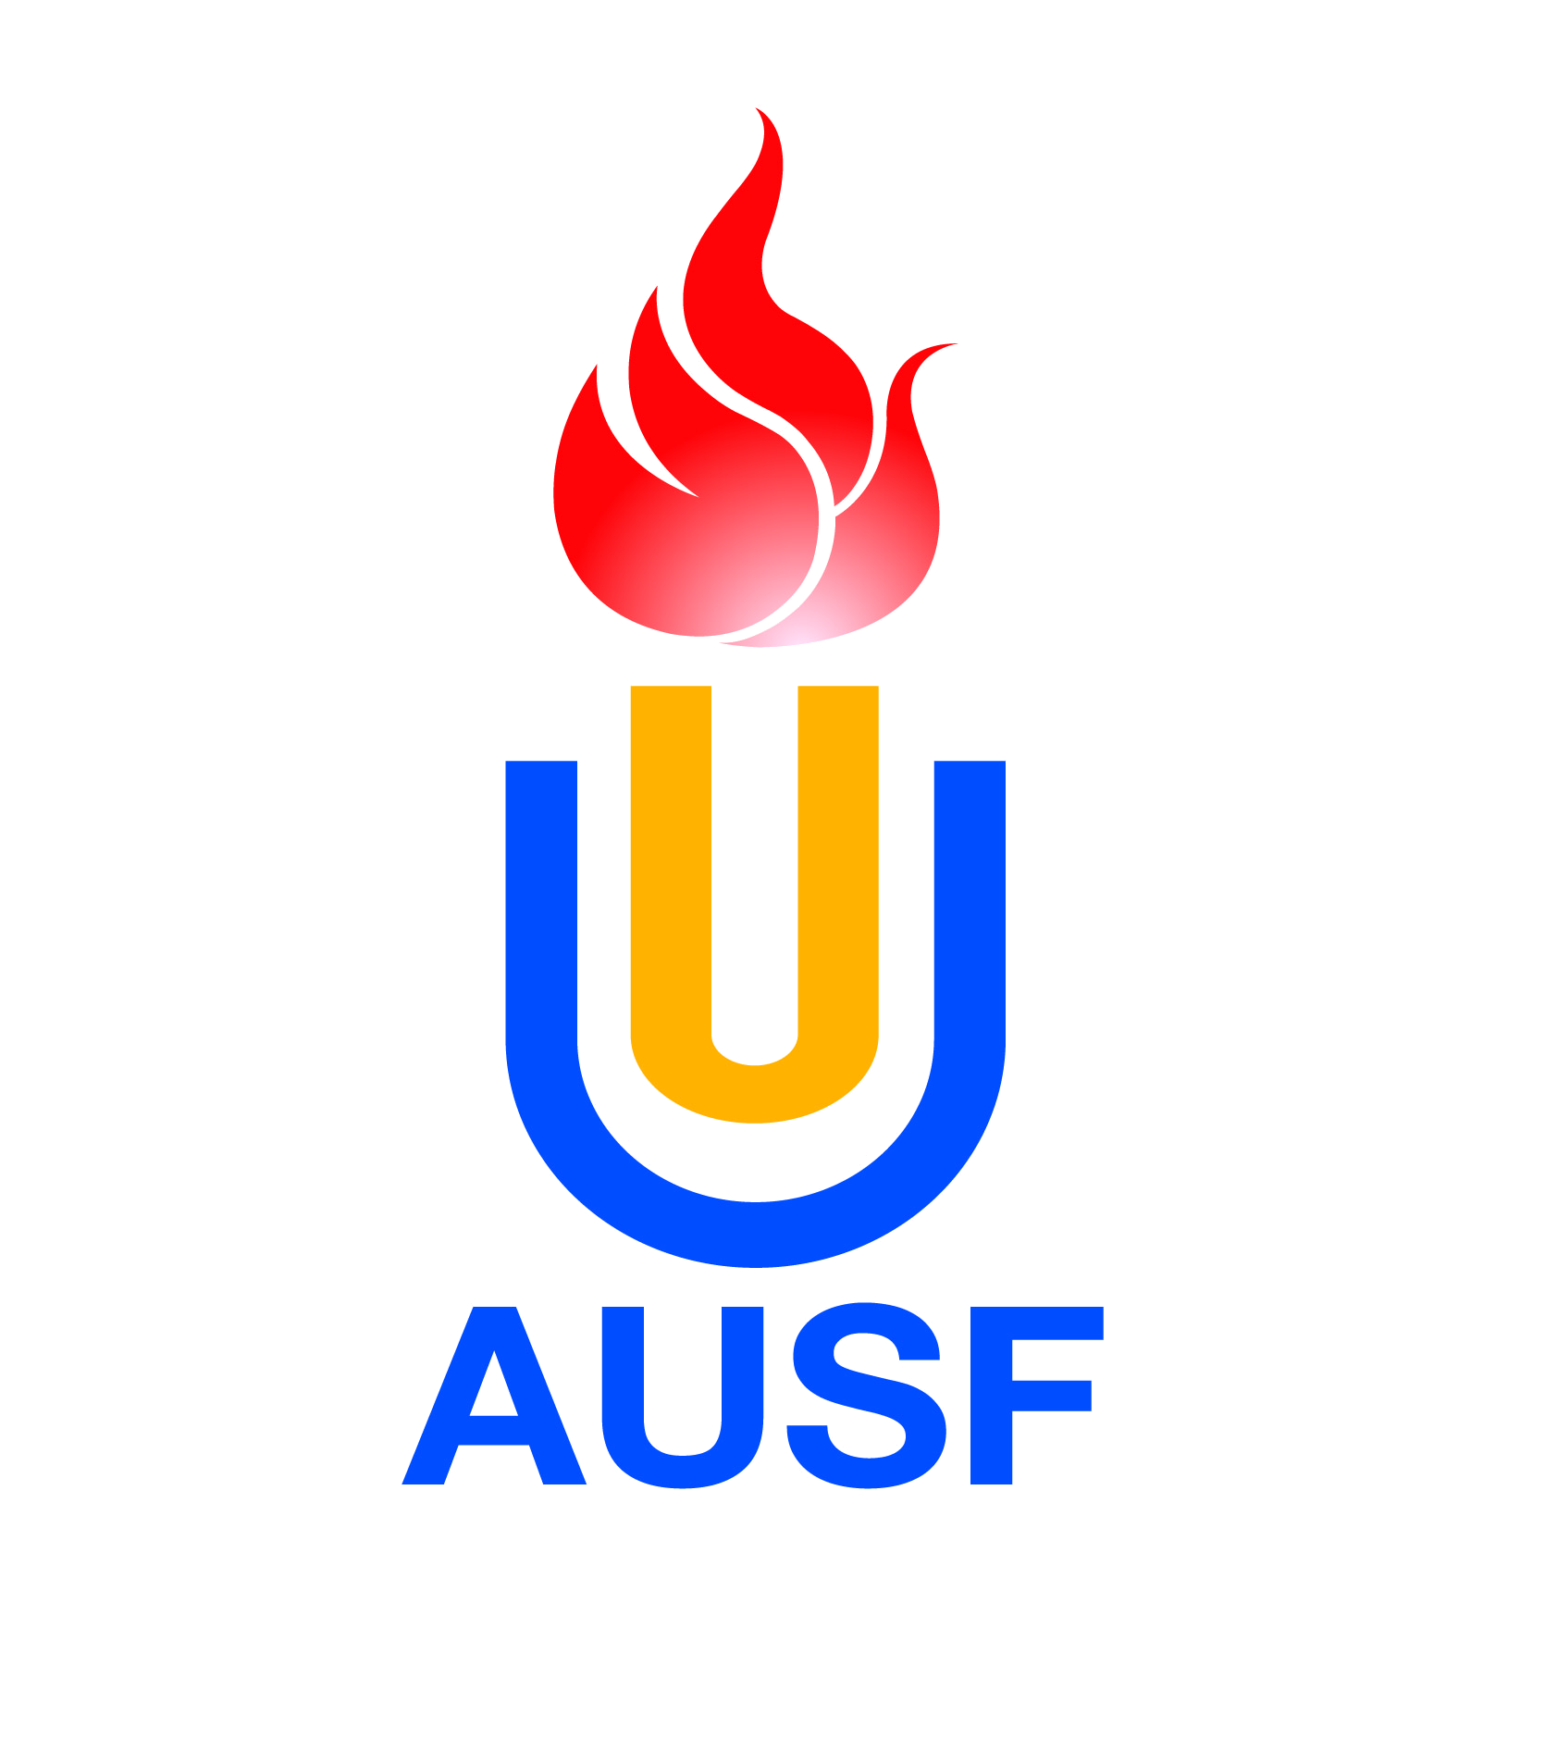  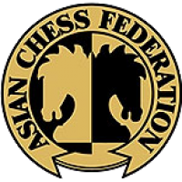 | 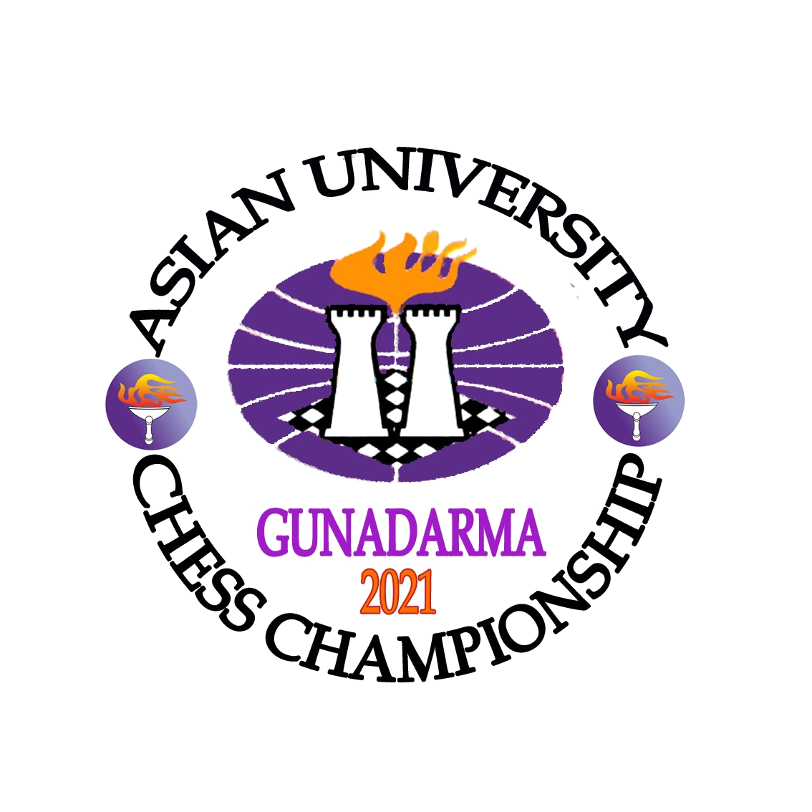 | 
Online, 2-13 September

Email: catur@gunadarma.ac.id, Tel:(+62) 21 78881114, Fax: (+62) 21 7872829,
Mobile Phone/ Whatsapp Number: (+62) 878 78600755
Individual Entry Form
(Officials)

 | Individual Entry Form  (Officials) |  | I2

Country/Region : |  | Country Code

 | Last Name |  |  | First Name |  |  |  |  | Passport/ID photo less than 50 KB
Roman Alphabet |  |  |  |  |  |  |  |  | Passport/ID photo less than 50 KB
Nationality |  |  |  |  | Sex | M | F |  | Passport/ID photo less than 50 KB
Date of Birth |  |  |  | Place of Birth |  |  |  |  | Passport/ID photo less than 50 KB
 | Year | Month | Day |  |  |  |  |  | Passport/ID photo less than 50 KB

Passport/ID Number
Address
City |  | Whatsapp |  | Country/Region
Phone |  | Fax |  | Email
Please check one of the following functions:
Head of Delegation | A |  |  | Team Leader | E |  |  | Physician | I
Deputy Head of Delegation | B |  |  | Team Official | F |  |  | Medical Personnel | J
Secretary | C |  |  | Technician | G |  |  | Media Liaison | K
Delegation Official | D |  |  | Coach | H |  |  | Other | L

By participating or otherwise appearing in an AUSF event, each competitor, participant, official and each officer, agrees to be filmed, televised, photographed, identified and otherwise recorded, under the conditions and for the purposes authorized by AUSF either currently or in the future, and in relation to the promotion of the Sporting, Cultural, and Educational activities organized under the aegis of AUSF or under its patronage.

I declare that the above athlete is a bona fide member of the delegation participating in the 2021 Asian University Chess Championship,that the information stated on this form is true to the best of my knowledge.

Entry to be sent back no later than 23 August 2021
The digital entry must be sent to the Organizing Committee (catur@gunadarma.ac.id), and copied to AUSF (ausf@ausf.org)
Please keep a copy for your own records.

Name and Signature of the President or Secretary General of the NUSF
Name |  | Function |  |  |  |  |  |  |  | Seal
Signature |  | Date |  |  |  |  |  |  |  | Seal
CIC Approval |  |  | 2021 | CIC | Category

For Official Use Only
Asian University Sports Federation
33-2, Ronghuiyuan, Yuhua Road, Shunyi District, Beijing, China
Tel: (86) 10 66093760, Fax: (86) 10 66093766
E-mail:ausf@ausf.org,http://www.ausf.org

