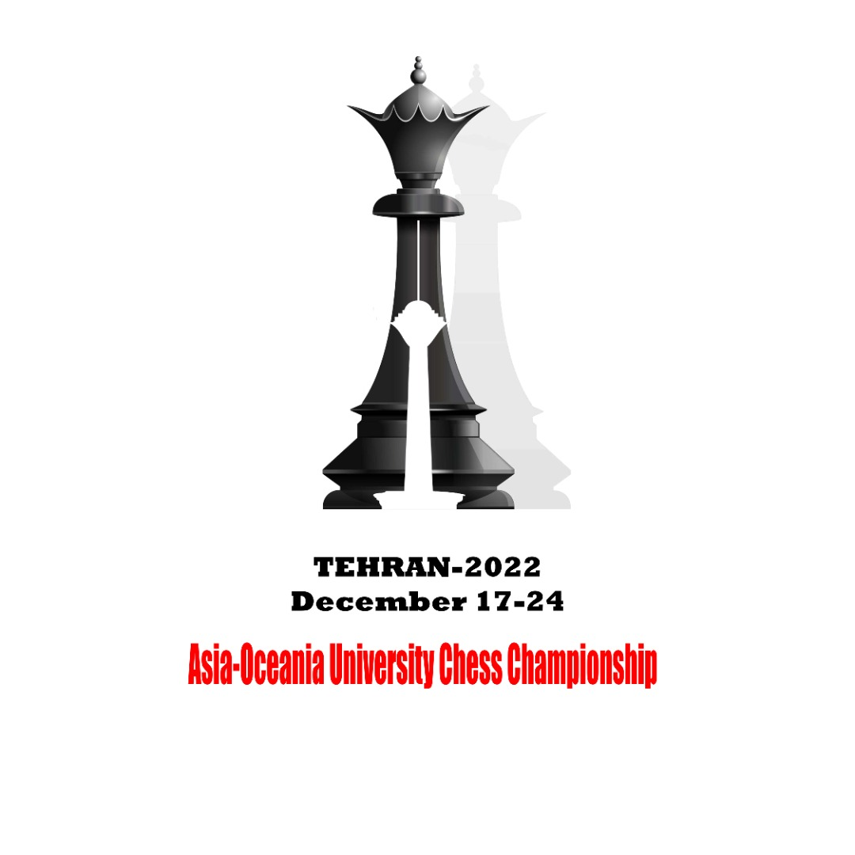 | 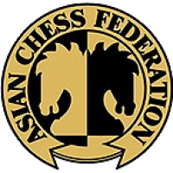 | 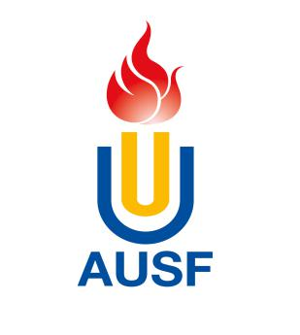

2022 Asia-Oceania University Chess Championship
Online, December 17th to 26th

OC Email: Irannusf@yahoo.com, Tel:+982188915251-3, Fax: +982188808732
Quantitative Entry Form
Q

Country/Region: |  | Country Code:
Name of the NUSF:

* National University Sports Federation (NUSF)

Please fill in this table a numerical estimation of participants.
Delegation | Men’s Individual | Women’s Individual
Players
Official
Total

Delegation
Each country/region is authorized to enter a maximum of ten (10) persons, of whom eight (8) may be players and two (2) officials.
Players
Each federation may enter one (1) team (a combined team or a university team) per gender. Each team consists of four (4) players.

Entry to be sent back no later than 17th, October 2022
The digital entry must be sent to the Organizing Committee (Irannusf@yahoo.com), and copied to AUSF (ausf@ausf.org)
Please keep a copy for your own records.

Name | Function
Signature | Date
Name and signature of the President or the Secretary General of the NUSF

Seal

NUSF

For Official Use Only
Asian University Sports Federation
33-2, Ronghuiyuan, Yuhua Road, Shunyi District, Beijing, China
Tel: (86) 10 66093760, Fax: (86) 10 66093766
E-mail:ausf@ausf.org,http://www.ausf.org

