|  |  |
| --- | --- |
|  |  |

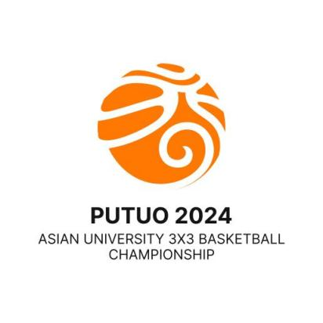



**6th Asian University 3x3 Basketball Championship**

11th - 13th June, 2024 Putuo, Zhoushan, China

OC Email: AUSF3X3PUTUO2024@163.com Tel:+86-18057477777

|  |  |  |  |  |  |  |  |  |  |
| --- | --- | --- | --- | --- | --- | --- | --- | --- | --- |
| Received on: | | **Quantitative Entry Form** | | | |  |  |  | |
|  | **Q** |  | |
| Country/Region: | |  | Country/Region Code |  | | | |
| Name of the NUSF: | |  | | | | | |

|  |
| --- |
| **\* National University Sports Federation (NUSF)** |

Please fill in this table a numerical estimation of participants.

|  |  |  |  |
| --- | --- | --- | --- |
| Delegation | | Male | Female |
| Competitors | Male Team 1 |  |  |
| Male Team 2 |  |  |
| Female Team 1 |  |  |
| Female Team 2 |  |  |
| Officials | |  |  |
| Head of Delegation | |  |  |
| **Total** | |  |  |

**Delegation**

Each country/region is authorized to enter a maximum of twenty-one (21) persons, of whom sixteen (16) may be competitors, four (4) officials and one (1) Head of Delegation (HOD); only when NUSF entering two (2) or more teams may include maximum of one (1) HOD.

**Competitors**

Each NUSF may send in a maximum of 2 men's teams and 2 women's teams. Each team may consist of a maximum of 4 players.

**Entry to be sent back no later than 22nd April, 2024**

The digital entry must be sent to the OC (AUSF3X3PUTUO2024@163.com), and copied to AUSF (ausf@ausf.org)

Original must be sent to the AUSF Secretariat.

Please keep a copy for your own records.

**Next Entries:** Individual Entry Form - **30th April, 2024**

**Name and signature of the President or the Secretary General of the NUSF**

|  |  |
| --- | --- |
| Name | Seal of NUSF  Function |
| Signature | Date |