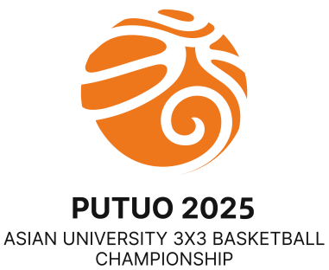 | 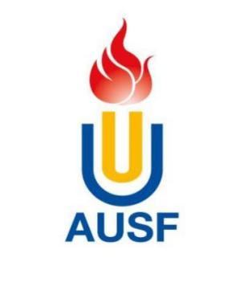 | 

7th Asian University 3x3 Basketball Championship
23th - 25th May, 2025 Putuo, Zhoushan, China
OC Email: AUSF3X3PUTUO2025@163.com Tel:+86-18057477777
Received on: |  | Quantitative Entry Form
 |  |  |  |  |  |  | Q
 | Country/Region: |  |  | Country/Region Code
 | Name of the NUSF:

* National University Sports Federation (NUSF)
Please fill in this table a numerical estimation of participants.
Delegation |  | Male | Female
Competitors | Male Team 1
 | Male Team 2
 | Female Team 1
 | Female Team 2
Officials
Head of Delegation
Total
Delegation
Each country/region is authorized to enter a maximum of twenty-one (21) persons, of whom sixteen (16) may be competitors, four (4) officials and one (1) Head of Delegation (HOD); only when NUSF entering two (2) or more teams may include maximum of one (1) HOD.
Competitors
Each NUSF may send in a maximum of 2 men's teams and 2 women's teams. Each team may consist of a maximum of 4 players.

Entry to be sent back no later than 30th March, 2025
The digital entry must be sent to the OC (AUSF3X3PUTUO2025@163.com), and copied to AUSF (ausf@ausf.org)
Original must be sent to the AUSF Secretariat.
Please keep a copy for your own records.
Next Entries: Individual Entry Form - 5th April, 2025

Name and signature of the President or the Secretary General of the NUSF
Name | Seal of NUSF  Function
Signature | Date

