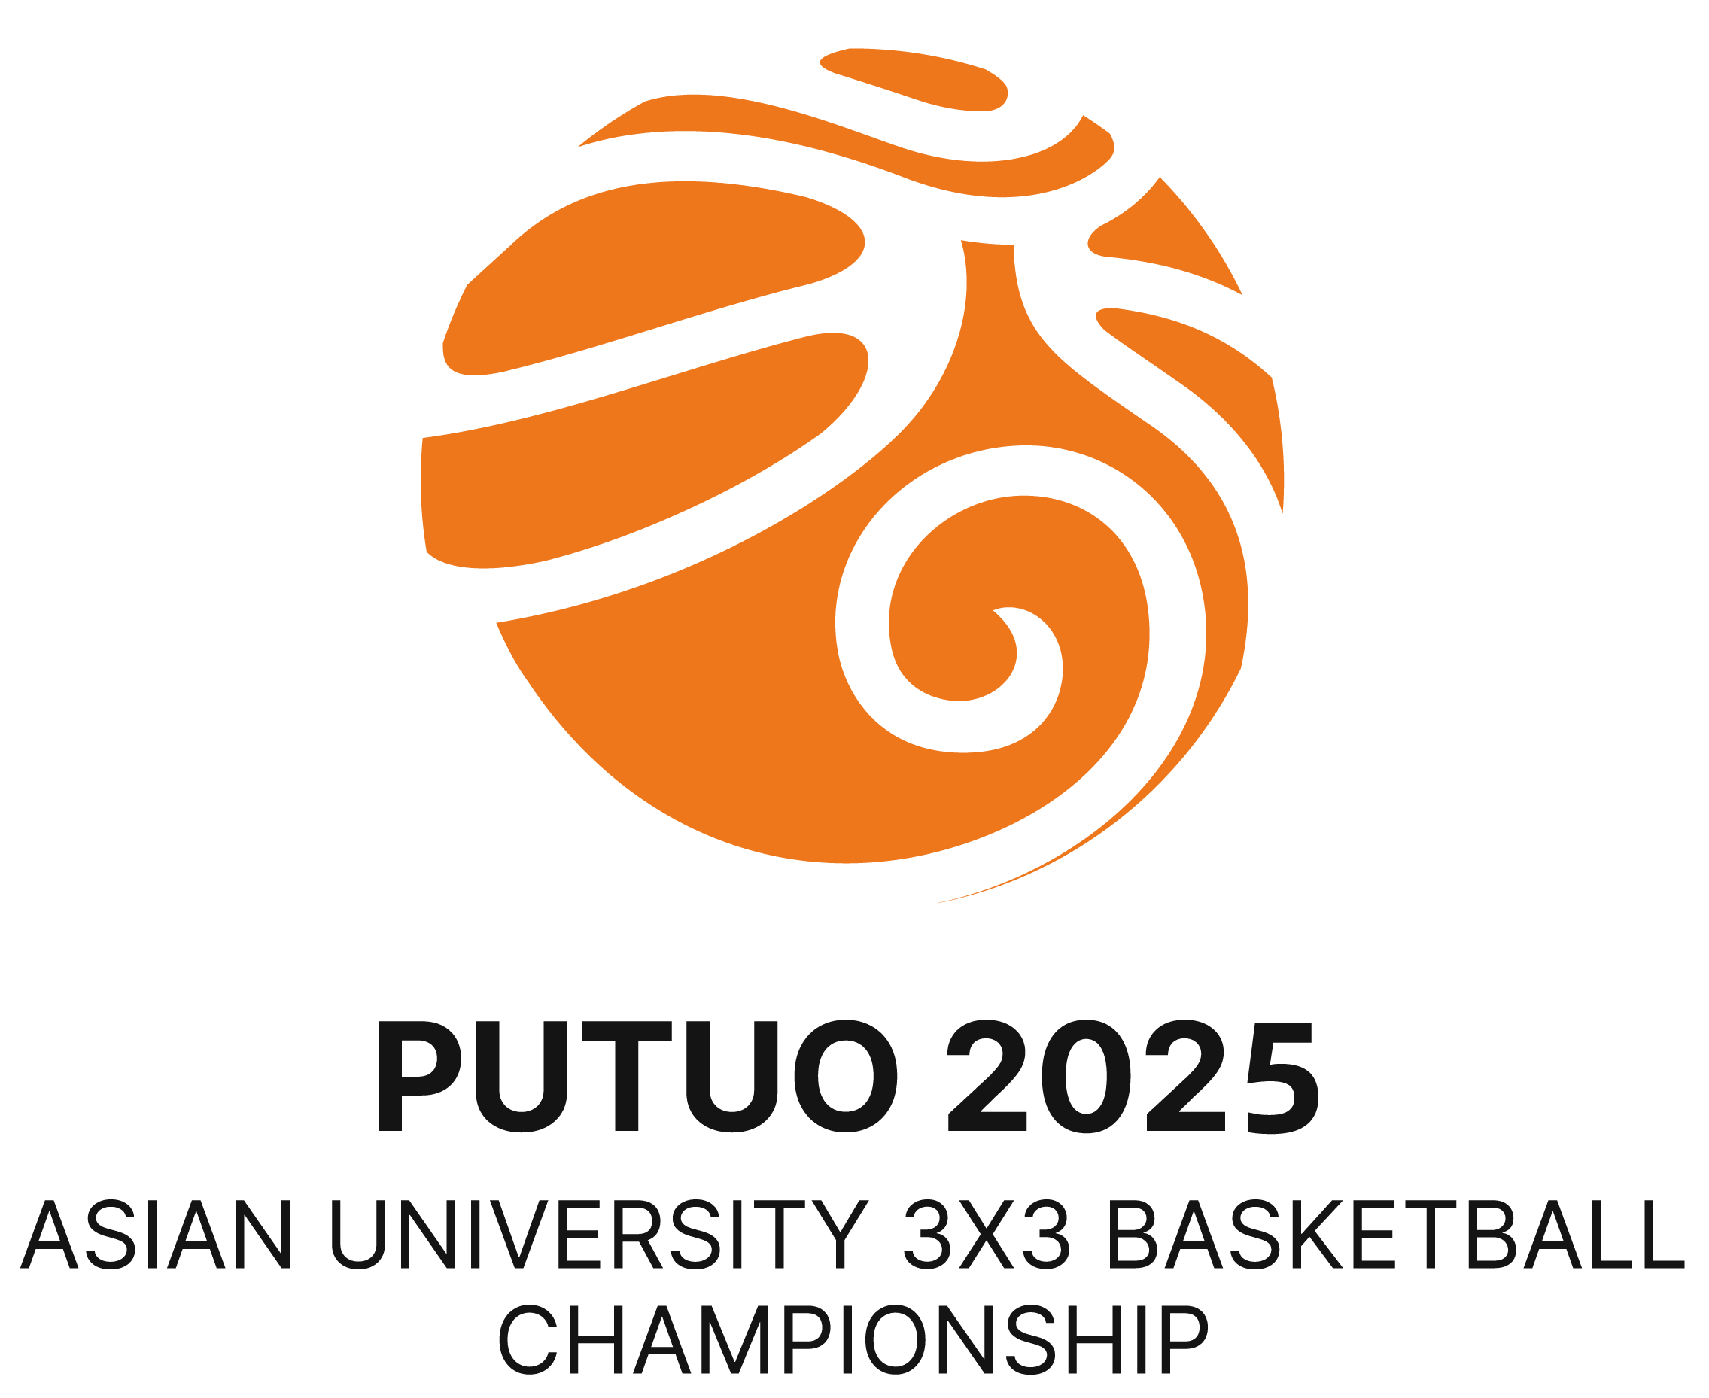 | 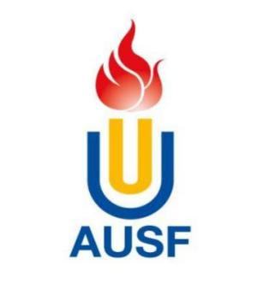 | 

7th Asian University 3x3 Basketball Championship
23th - 25th May, 2025 Putuo, Zhoushan, China
OC Email: AUSF3X3PUTUO2025@163.com Tel:+86-18057477777

Academic Eligibility
Country/region |  | Country/Region Code
Name of NUSF:
To be completed by competitor
Last Name
First Name
Nationality |  | Place of Birth
Date of birth |  | Passport No.
Name of University
Faculty/School |  | Year of study
I certify to the best of my knowledge that the above Academic Record is correct.
To be completed by the University or Educational Authority
Name and Signature of University or Educational Authority Representative

Name

Official Seal

Signature_

Date

To be completed by NUSF
Name and Signature of the NUSF President or Secretary General

Official Seal

Name

Signature_

Date

WARNING
The information given above must be accurate and to the best of the signatories’ knowledge at the date indicated below. Any false information will lead to disqualification. Should any information change, please inform immediately.

AUSF Regulations
Participation
Only competitors who meet the following conditions may participate in this Championship:
a. Be full-time students who are currently officially registered as proceeding towards a degree or diploma at a university or similar institute whose status is recognised by the appropriate national academic authority of their country or region;
b. Be former students who have obtained their academic degree or diploma in the preceding year;
c. Be at least 18 and less than 25 years of age on the 31 st December of the year of the event: athletes must be born between 01/01/2000 and the 31/12/2007;
d. Be a student of the university (no matters the nationality) they represent;
e. Students from the same team must be registered in the same university.

