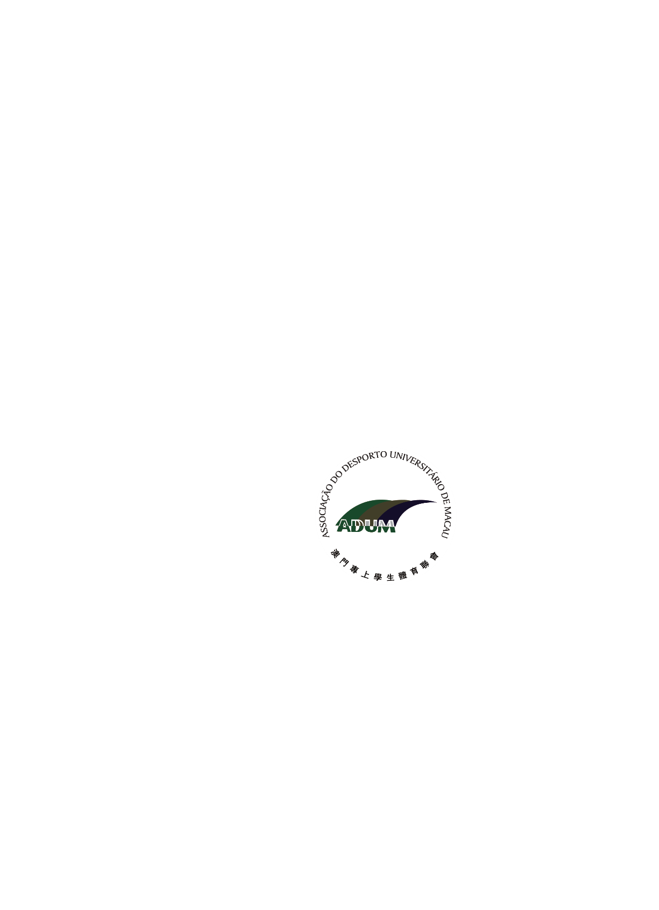

**1st Asian University Karate Championship 2019**

**Macau, China 16th -17th April, 2019**

**General Entry Form**

Received on:

Country / Region

Country/Region Code

## * National University Sports Federation – NUSF

|  |  |  |  |  |  |
| --- | --- | --- | --- | --- | --- |
| Name of the NUSF |  | | | | |
| Address |  | | | | |
| City |  | | | Postal  Code |  |
| Telephones | #1. | | #2. | | |
| Tele fax |  | E-mail |  | | |

*In case of non-affiliation to AUSF, the National Olympic Committee or similar national organization

which groups together the students of that country.

## Contact Person

|  |  |  |  |
| --- | --- | --- | --- |
| Family Name |  | | |
| Given Name |  | | |
| Function |  | | |
| Telephones | Office/ Bureau | Mobile |  |
| Tele fax |  | E-mail |  |

Entry to be submitted online no later than (d/m/y) **18/01/2019** Name and Signature of the President or Secretary General of the NUSF / or the NSF Representative (only for non-member associations)

|  |  |
| --- | --- |
| Name | Function |
| Signature | Date |

Seal NUSF if not NSF

Entries arriving after the expiration of the required deadlines will not be taken into consideration, except in the case of circumstances outside one’s control, with the agreement of the Executive Committee and on the advice of the Organizing Committee.

## Asian University Sports Federation

Bldg.33-2 Ronghuiyuan, Yuhua Rd., Block B, Kongganggongyequ, Shunyi district, Beijing – China, Tel : +86 (10) 66093756, 66093764, Fax: +86 (10) 66093766,

E-mail: ausf@ausf.org; Website: [http://www.ausf.org](http://www.fisu.net/)